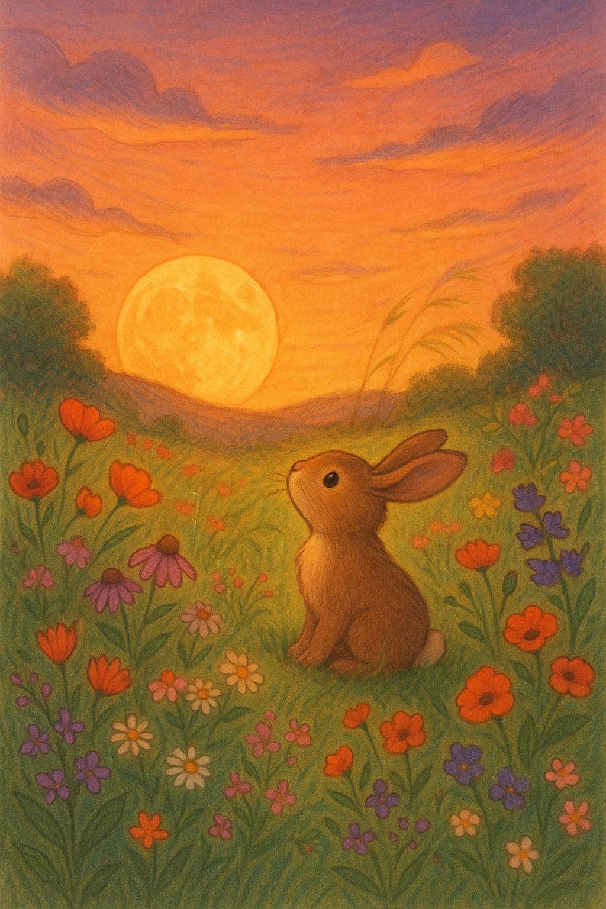**The Little Bunny and the Golden Moon**

***By: Israel Ohayon***

**Chapter 1: The Garden and the Golden Sky**

**On a peaceful evening, just as the sun tucked itself under the horizon and painted the sky in soft oranges and purples, a little bunny named Lulu sat quietly in his cozy garden.**

**The trees rustled gently in the breeze, and the air smelled like sweet flowers. Lulu looked up and gasped—floating above was a glowing golden moon, smiling kindly from the sky.**

**“Hello, Moon!” Lulu said.  
“Hello, little bunny!” the moon replied. “You look like you could use a friend.”**

**And just like that, their magical friendship began.**

**Chapter 2: A Leap to the Moon**

**The next night, the moon returned, glowing even brighter than before.**

**“Would you like to play with me?” the moon asked.**

**Lulu’s ears perked up. “Yes! But how do you play with a moon?”**

**“Hop as high as you can,” said the moon, “and I’ll light your way!”**

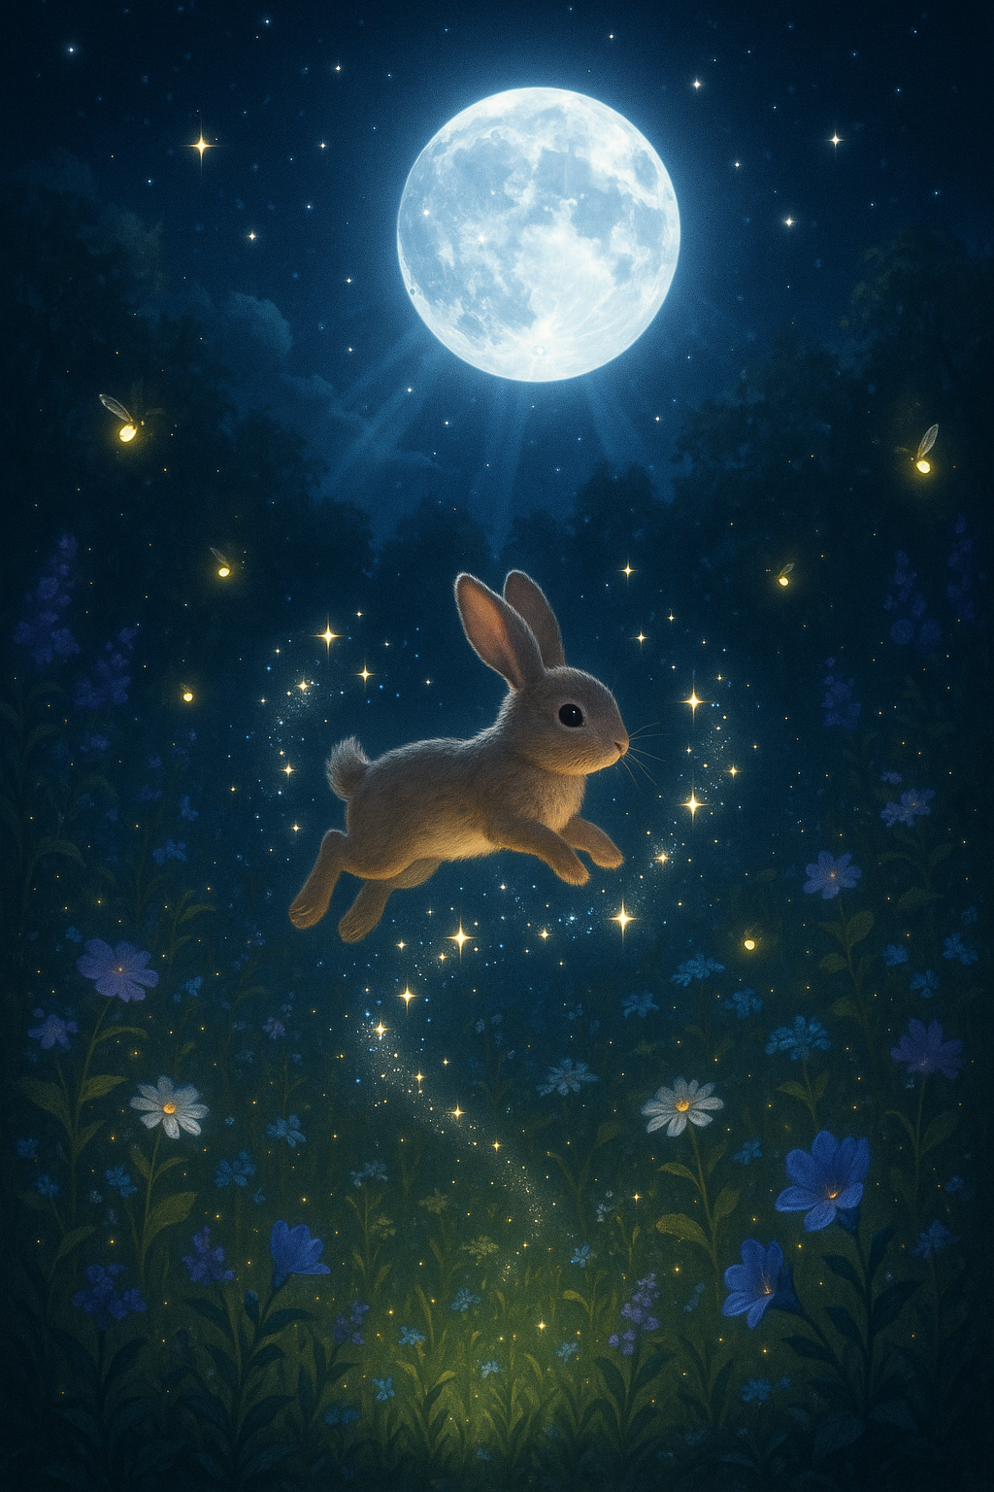**Lulu hopped, then again—each jump higher than the last. As he leapt, the moon beamed golden light over the garden, and something magical happened: sparkles of starlight danced in the air around him.**

**Lulu laughed with delight.**

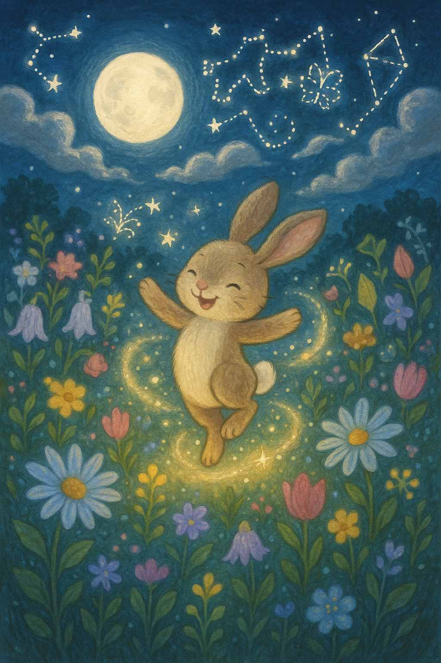

**Chapter 3: Moonlight Magic**

**As the days passed, Lulu learned something new—each kind of hop made the moon do something special.**

**A twirl made the stars swirl.  
A little spin made the flowers glow.  
When he laughed, the clouds shimmered silver.**

**The moon had become a magical friend, and Lulu began calling him Mr. Moonbeam.**

**“Mr. Moonbeam,” Lulu giggled one night, “do you know any moon tricks?”**

**“Only when my friends believe in them,” the moon whispered.**

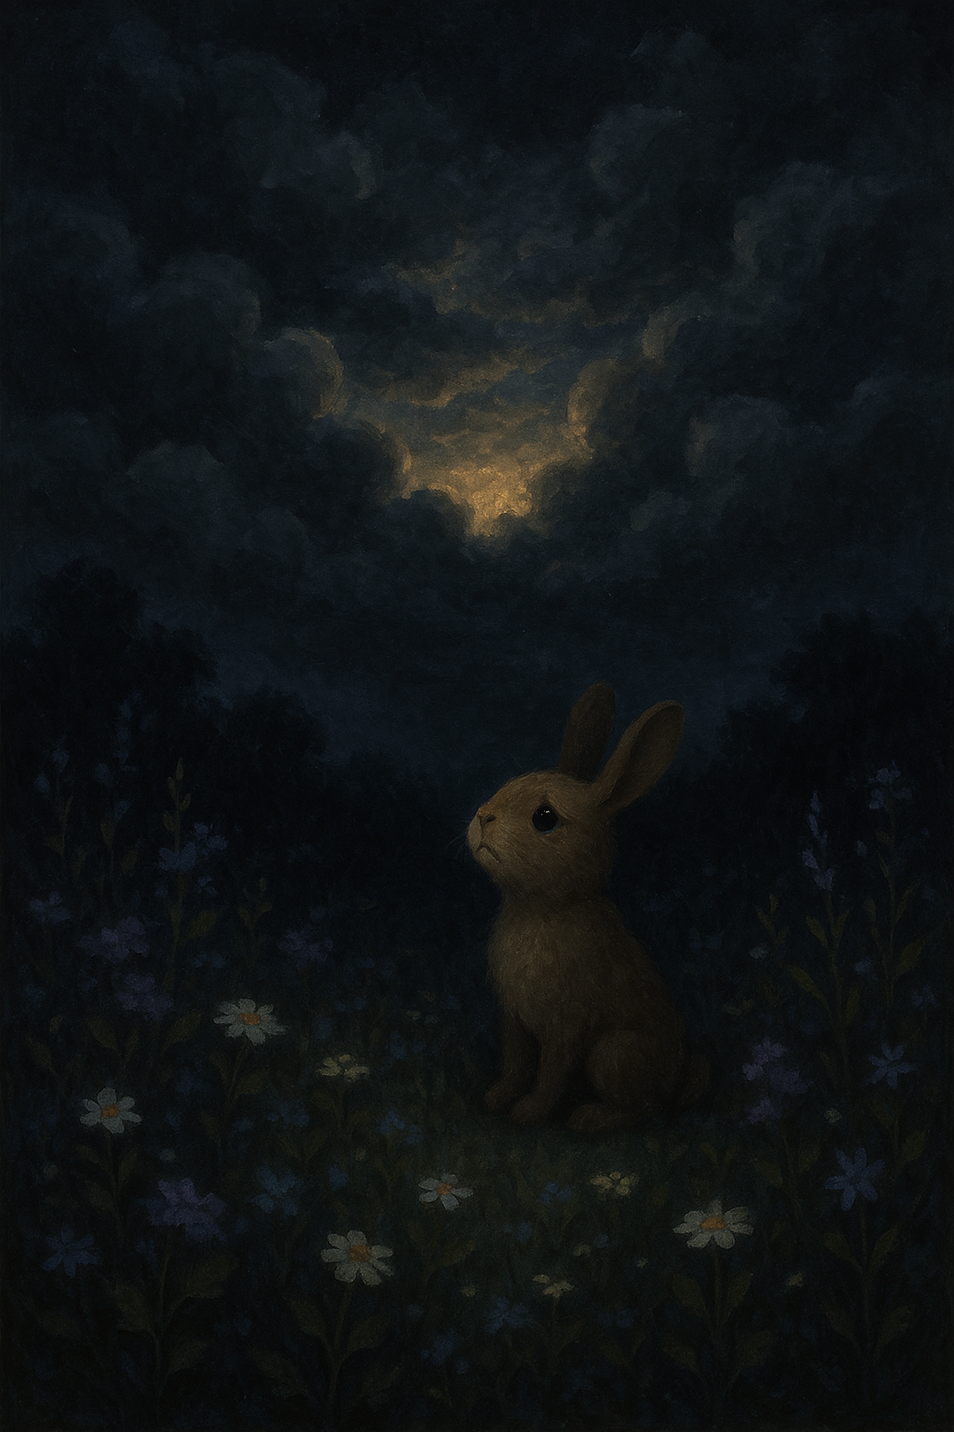

**Chapter 4: The Cloudy Night**

**One night, Lulu ran outside excitedly—but the moon was gone. Thick gray clouds covered the sky.**

**“Moon? Where are you?” he called.**

**There was no answer. The wind howled and the stars were hidden.**

**Lulu sat alone, his ears drooping.**

**Then he remembered: “If I hop and say hello…”**

**He hopped once, softly.  
Then again, a little higher.**

**Suddenly, a soft glow peeked through the clouds—just a sliver of golden light. The moon was trying to reach him.**

**“I’m here,” the moon whispered gently. “Even behind clouds, I never leave you.”**

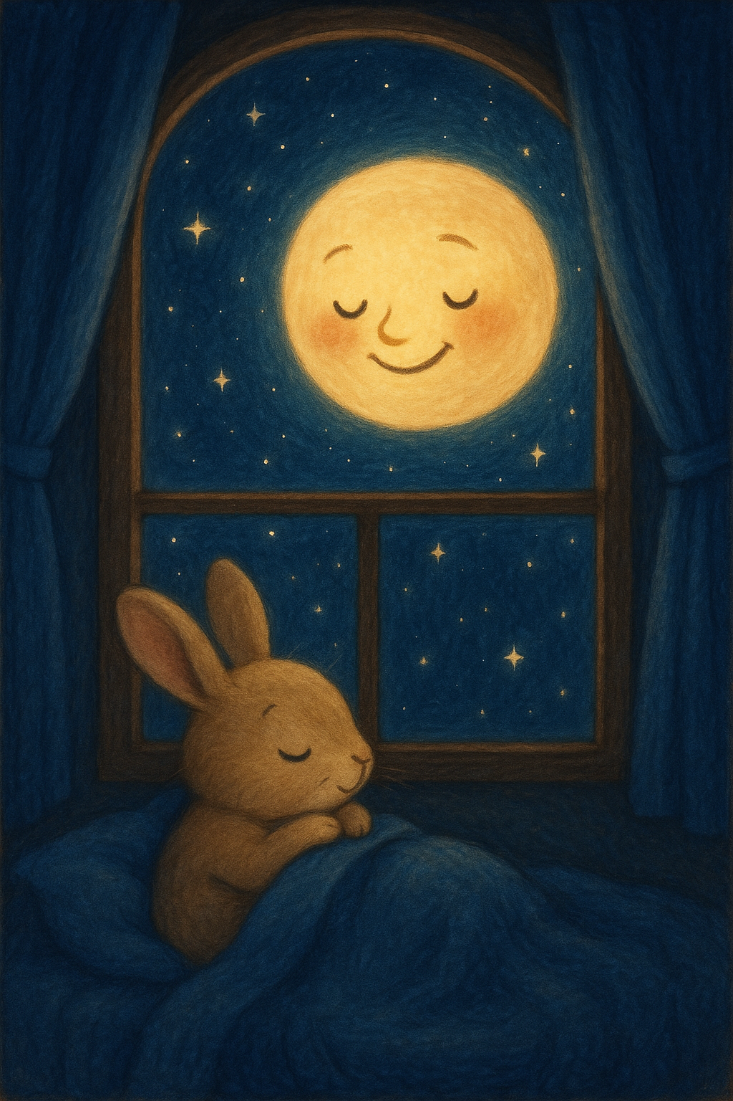**Chapter 5: Forever Friends**

**After that night, Lulu knew: the moon would always be there.**

**Every evening, they played.  
Some nights, Lulu danced. Other nights, he just whispered stories to the moon.  
And the moon would reply with glowing light and soft stardust kisses.**

**Before bed, Lulu always said:**

**“Good night, kind moon. Dream sweet dreams.”**

**And the moon always replied:**

**“Good night, Lulu. I’ll be right here, watching over you.”**

**And so it was, night after night—one little bunny, one golden moon, and a magical friendship that lit up the sky.**

THE END!